Gates EWP EOL Tester

User Manual

Contents

1.0 Overview 3

2.0 User Interface 4

2.1 Test & Report Page 4

2.2 Data Acquisition Page 5

2.3 Manual Page 6

2.4 Settings Page 7

3.0 Test Profiles 8

3.1 set_ps_volt_setpoint 8

3.2 set_ps_current_limit 8

3.3 set_ps_enable_output 8

3.4 set_pwm_duty_cycle 9

3.5 dwell_seconds 9

3.6 display_user_dialog 9

3.7 check_result 9

3.8 connect_lcr 10

3.9 disconnect_lcr 10

3.10 tare_lcr 10

3.11 configure_lcr_measurement 10

4.0 Signal List 11

# Overview

The Gates EWP EOL Tester is a LabVIEW-based application allowing the end-user to run configurable end-of-line test procedures. The application communicates with NI-DAQmx data acquisition hardware, a BK Precision LCR meter for inductance and resistance measurements, and a BK Precision 9115 Power Supply for powering the EWP to run speed profiles.

The application will run a configurable CSV-based test profile to execute the test and display results and prompts to the user. The data from the test run will be stored in a CSV format after the test has completed.

# User Interface

The user interface (UI) is separated into multiple tabs for different features of the application.

## Test & Report Page

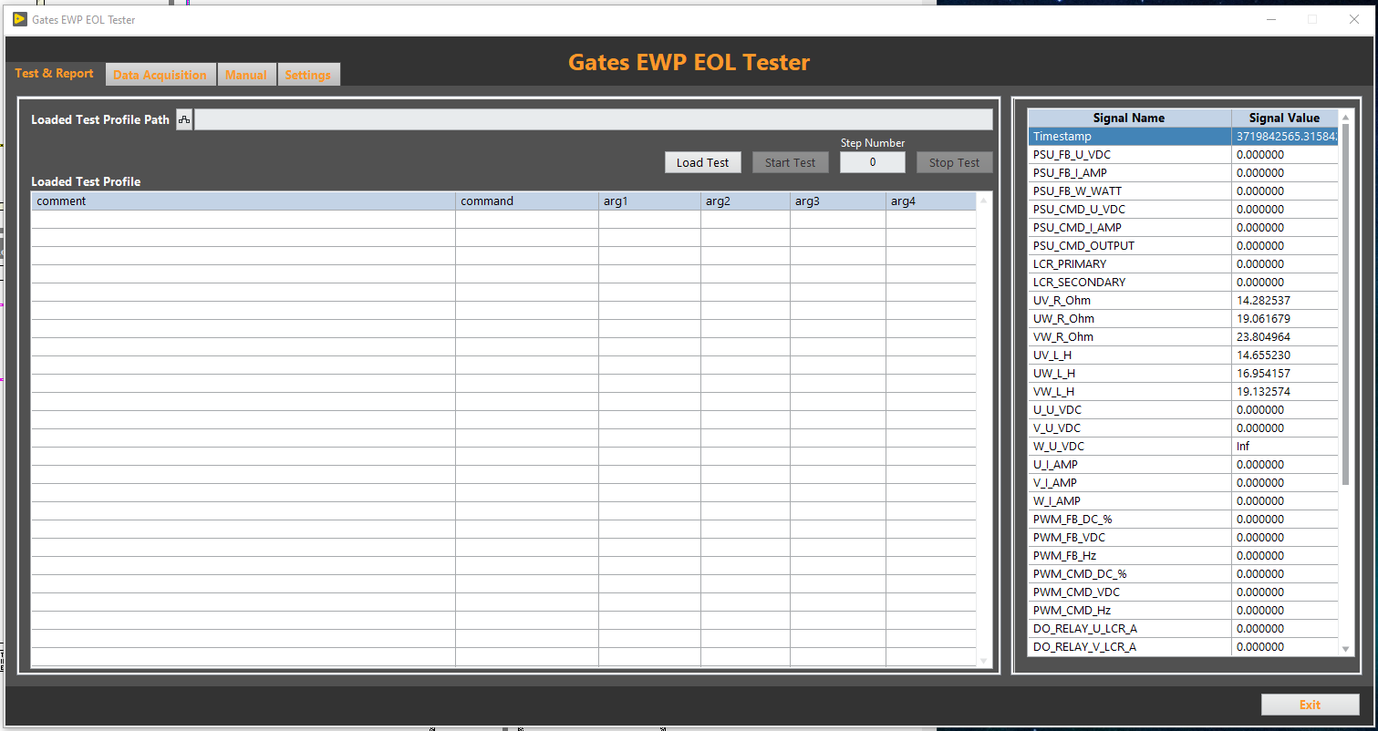

This page is where the user can run a test procedure and view live report data as the test is running. A test can be loaded from the **Load Test** button and **Start Test** will execute the test. **The Loaded Test Profile** will show what step is currently being executed and display all the steps within the test. Live data is updated on the right-hand side of the page and this data will be highlighted green or red based on the pass/fail output of the running test profile.

## Data Acquisition Page

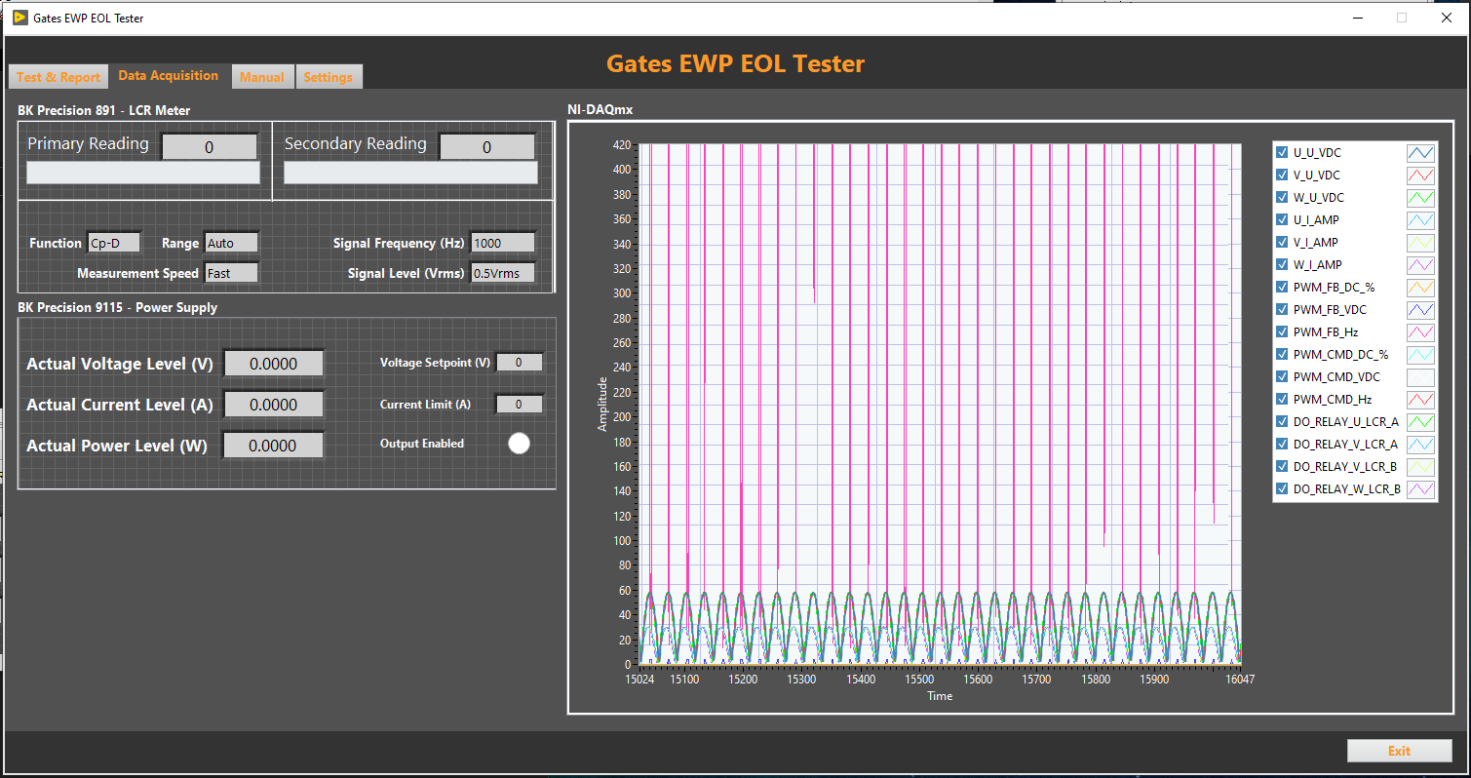

The data acquisition page provides a live data chart for the NI DAQmx signals and displays live feedback from the BKP LCR Meter and BKP Power Supply. Individual signals can be added/removed from the live chart with the checkboxes next to them. This page also shows some of the configuration settings/setpoints of the hardware devices and their current values.

## Manual Page

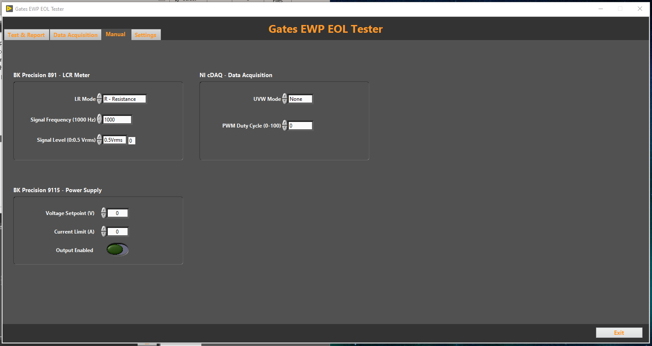

The manual page is used for manually controlling the hardware before/after running a test. It allows configuring the BKP LCR Meter, BKP Power Supply, and NI-DAQmx relays for UV, UW, VW configuration. It also allows the user to set a PWM duty cycle command to the EWP.

## Settings Page

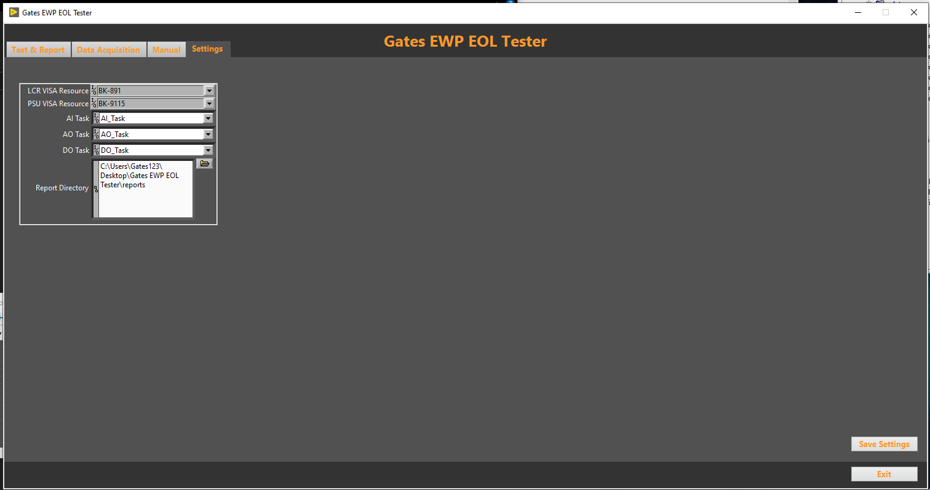

The settings page is used to save system configuration settings. The primary setting that the user would be interested in changing would be the **Report Directory** which tells the application where to store test profile data. The user should not need to change any other settings unless the hardware has been replaced or is at a different location. Once settings are changed the **Save Settings** button will write the changes back to the configuration file so that the settings persist and are restored at the next launch of the application.

# Test Profiles

The application supports creating test profiles via CSV files with a set of defined commands and user-defined arguments. Multiple example profiles are provided with the application for reference, as well as this section which describes the allowed commands/arguments for the test profile.

The profile is executed top-down and sequentially. The CSV file will contain one row for each command that the profile should execute. The first column is the command name and subsequent columns are arguments to that command.

The structure of the CSV test profile row is as follows…

*comment,command,arg1,arg2,…,argN*

The supported test profile commands/arguments are listed below.

## set_ps_volt_setpoint

Set the power supply voltage setpoint in VDC.

*set_ps_volt_setpoint,<setpoint_in_vdc>*

Example: **set_ps_volt_setpoint,12**

## set_ps_current_limit

Set the power supply current limit in Amps.

*set_ps_current_limit,<limit_in_amps>*

Example: **set_ps_current_limit**,**5**

## set_ps_enable_output

Set the power supply output enabled state to on/off (true/false).

*set_ps_enable_output,<True/False>*

Example: **set_ps_enable_output,True**

## set_pwm_duty_cycle

Set the PWM duty cycle output to the EWP.

*set_pwm_duty_cycle,<0-100>*

Example: **set_pwm_duty_cycle,50**

## dwell_seconds

This step will wait for the defined number of seconds before executing the next step.

*dwell_seconds,<seconds_to_dwell>*

Example: **dwell_seconds,10**

## display_user_dialog

Displays a message to the user and allows setting a timeout before the dialog auto-closes and continues on – this dialog can be used to prompt the user to perform a manual action before continuing with the test.

NOTE: The message cannot contain commas as commas are used to separate column data in CSV files.

*display_user_dialog,<message_to_user>,<timeout_in_seconds>*

Example: **display_user_dialog,Hello world!,60**

## check_result

This command is used to perform a pass/fail check on a signal. The signal that passed/failed will be highlighted on the Test & Report page as green for pass and red for fail. A list of signals can be found in section 4.0 of this document. The command allows for the test to continue if the check failed or to stop the test if the check failed.

*check_result,<signal_name>,<lower_bound_numeric>,<upper_bound_numeric>,<continue_if_fail_boolean>*

Example: **check_result,PSU_FB_U_VDC,11,13,True**

## connect_lcr

This command will configure the relays to connect/disconnect the phases U,V,W together for measurements with the LCR meter.

*connect_lcr,<0=UV, 1=UW, 2=VW>*

Example: **connect_lcr,0**

## disconnect_lcr

This command will disconnect the UVW phase relays entirely so that nothing is connected to the LCR meter.

Example: **disconnect_lcr**

## tare_lcr

This command will tare the LCR readings with the current values.

Example: **tare_lcr**

## configure_lcr_measurement

This command will configure the LCR meter for the specified measurement mode.

configure_lcr_measurement,<0=Resistance, 1=Inductance>,<Frequency Hz>,<0 = 0.5VRMS, 1 = 1VRMS>

Example: **configure_lcr_measurement,0,1000,0**

# Signal List

Below is the most-recent list of signals that the application provides data for.

* Timestamp
* PSU_FB_U_VDC
* PSU_FB_I_AMP
* PSU_FB_W_WATT
* PSU_CMD_U_VDC
* PSU_CMD_I_AMP
* PSU_CMD_OUTPUT
* U_U_VDC
* V_U_VDC
* W_U_VDC
* U_I_AMP
* V_I_AMP
* W_I_AMP
* LCR_PRIMARY
* LCR_SECONDARY
* UV_R_Ohm
* UW_R_Ohm
* VW_R_Ohm
* UV_L_H
* UW_L_H
* VW_L_H
* DIFF_UV_UW_L_H
* DIFF_UV_VW_L_H
* DIFF_UW_VW_L_H
* DIFF_UV_UW_R_Ohm
* DIFF_UV_VW_R_Ohm
* DIFF_UW_VW_R_Ohm
* DIFF_UV_U_VDC
* DIFF_UW_U_VDC
* DIFF_VW_U_VDC
* PWM_CMD_DC_%
* PWM_CMD_VDC
* PWM_CMD_Hz
* PWM_FB_DC_%
* PWM_FB_VDC
* PWM_FB_Hz
* DO_RELAY_U_LCR_A
* DO_RELAY_V_LCR_A
* DO_RELAY_V_LCR_B
* DO_RELAY_W_LCR_B